TASK 3 – UI CLONE CHALLENGE
Chroma Stream – OTT Streaming Platform UI

1. Objective
The objective of this project is to design and develop a modern OTT streaming platform user interface inspired by real-world streaming websites. This project focuses on responsive web design, frontend development, component-based UI creation, animations, and deployment techniques.
The project helped in understanding modern web technologies, responsive layouts, UI/UX concepts, and GitHub workflow.

2. Technologies Used
• HTML5
• CSS3
• JavaScript ES6+
• React JS
• Tailwind CSS
• GitHub
• Lovable AI

3. Features of the Project
• Fully Responsive OTT Platform UI
• Premium Hero Banner Section
• Trending Movies Cards
• Responsive Navigation Bar
• Smooth Animations and Hover Effects
• Mobile Responsive Design
• Dark Theme Interface
• Interactive Buttons and Sections
• Professional Footer Design
• Reusable UI Components

4. Project Description
Chroma Stream is a modern OTT streaming platform interface developed using modern frontend technologies. The application is inspired by professional streaming websites and provides a cinematic user experience with attractive layouts, animations, and responsive sections.
The project demonstrates frontend development skills including responsive web design, reusable components, deployment workflow, and modern UI design practices.

5. Folder Structure
chroma-stream/
│
├── public/
├── src/
│ ├── components/
│ ├── pages/
│ ├── assets/
│ └── styles/
│
├── package.json
├── tailwind.config.js
└── README.md

6. Screenshots
Figure 1: Homepage UI

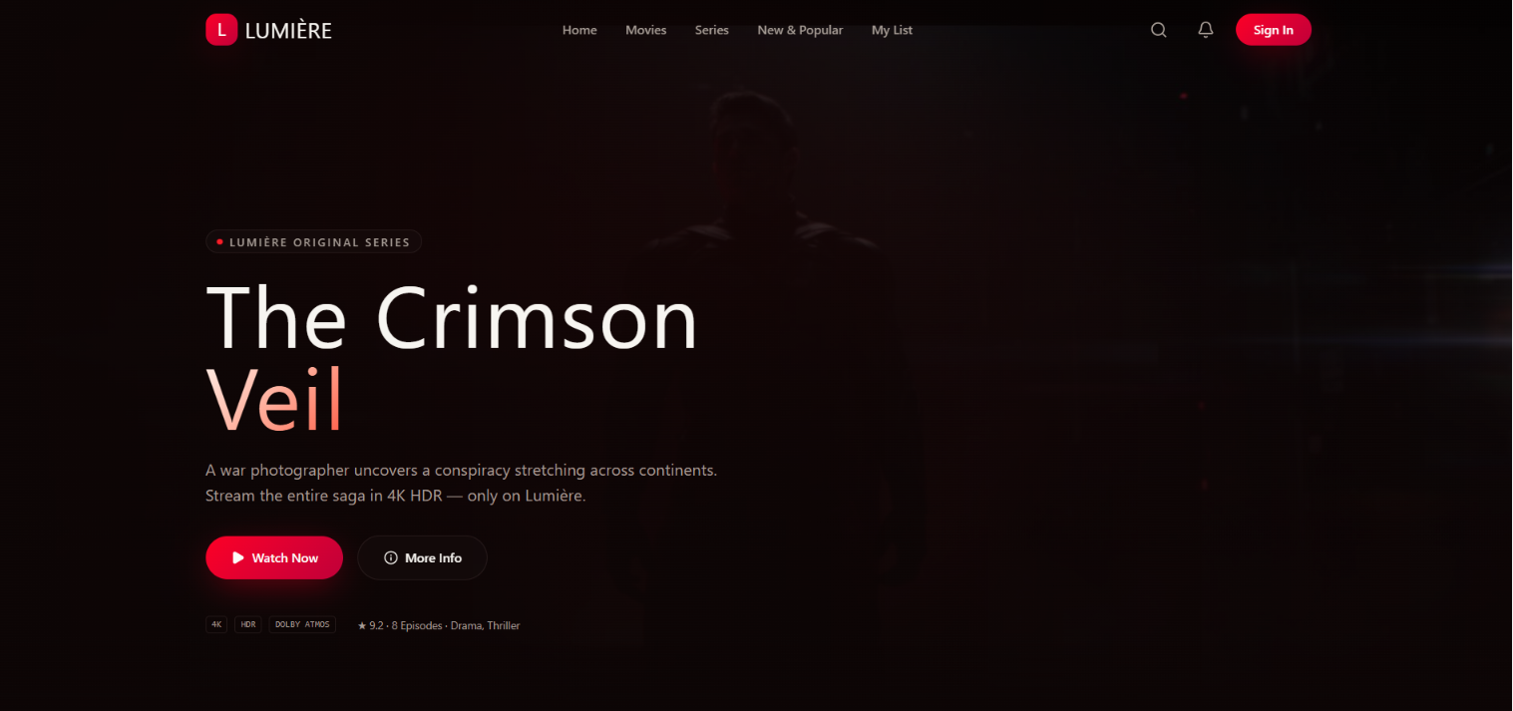
Figure 2: Hero Section

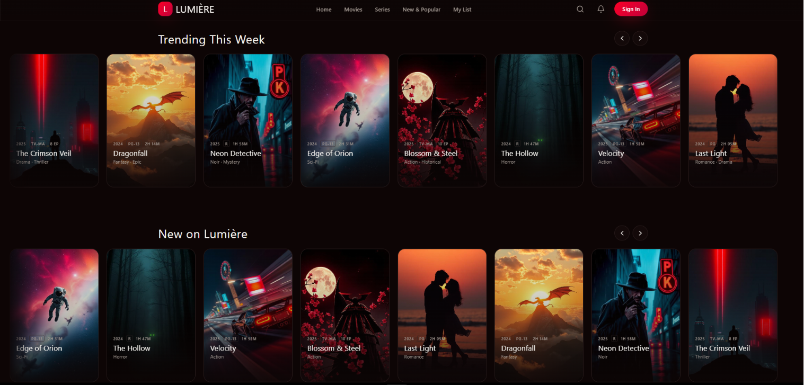
Figure 3: Trending Movies Section
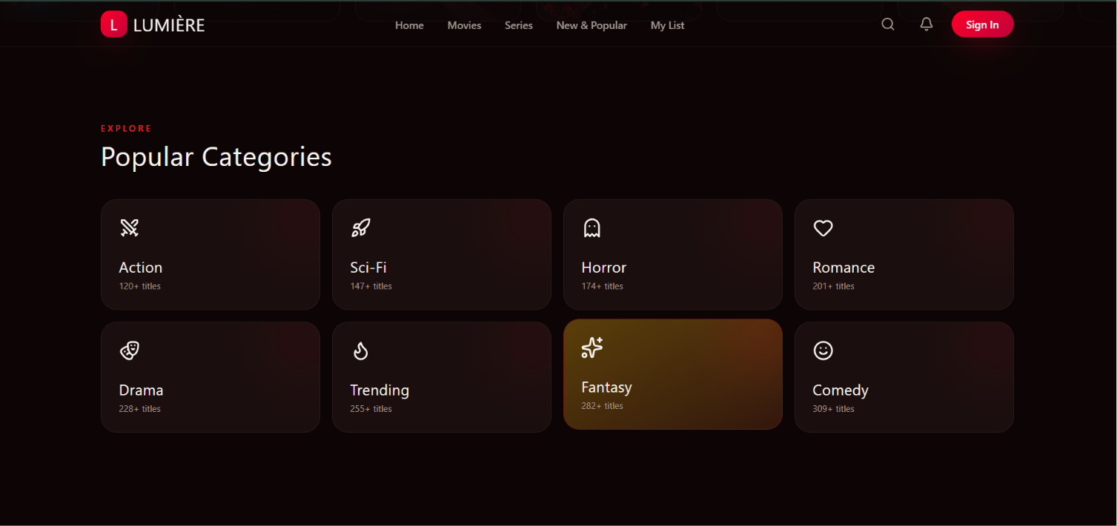
Figure 4: Responsive Mobile View

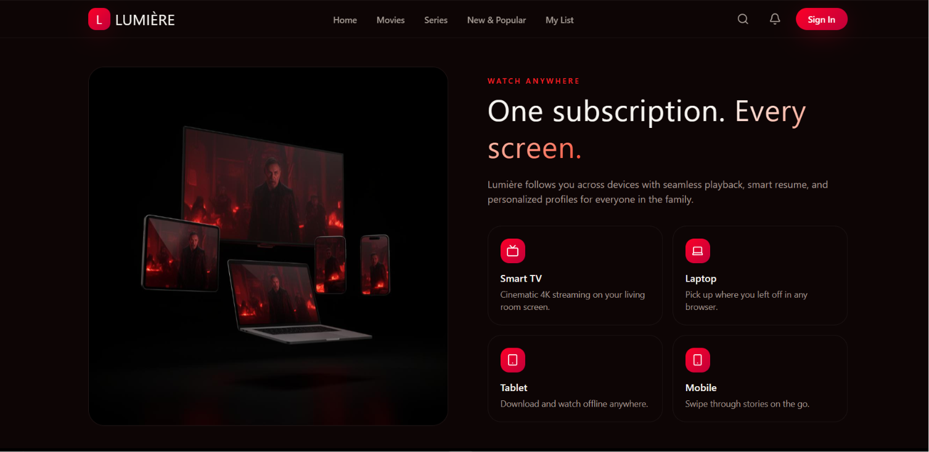
Figure 5: Footer Section
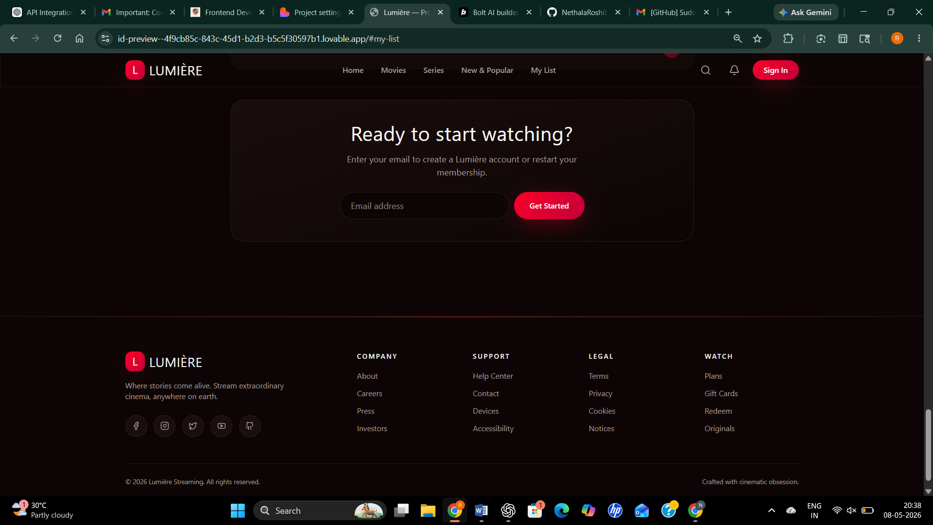

7. Important Code Snippets

HTML / JSX Snippet
<section className="hero-section">
<h1>Unlimited Streaming Experience</h1>
<button>Watch Now</button>
</section>

CSS / Tailwind Snippet
.hero-section{
height:100vh;
display:flex;
justify-content:center;
align-items:center;
}

JavaScript Snippet
window.addEventListener("scroll", () => {
console.log("User is scrolling");
});

8. Commands Used
npm install
npm run dev
git init
git add .
git commit -m "Initial Commit"
git push origin main

9. GitHub Repository Link
https://github.com/NethalaRoshitha/-UI-Clone

10. Hosted Website Link
https://stream-aura-22.lovable.app/

11. Challenges Faced
• Designing responsive layouts
• Creating smooth UI animations
• Managing mobile responsiveness
• Structuring reusable frontend components
• Improving visual alignment and spacing

12. Learning Outcomes
• Learned responsive frontend development
• Improved React and Tailwind CSS knowledge
• Understood deployment workflow
• Learned GitHub repository management
• Improved UI/UX design understanding

13. Conclusion
This project helped in gaining practical experience in frontend development and modern UI design. It improved understanding of responsive web design, reusable components, deployment techniques, and GitHub workflow. The project also enhanced creativity and practical development skills.

